**Project Report – CAR RESALE VALUE PREDICTION**

1. **INTRODUCTION** 
   1. Project Overview
   2. Purpose
2. **LITERATURE SURVEY**
   1. Existing problem
   2. References
   3. Problem Statement Definition
3. **IDEATION & PROPOSED SOLUTION**
   1. Empathy Map Canvas
   2. Ideation & Brainstorming
   3. Proposed Solution
   4. Problem Solution fit
4. **REQUIREMENT ANALYSIS**
   1. Functional requirement
   2. Non-Functional requirements
5. **PROJECT DESIGN**
   1. Data Flow Diagrams
   2. Solution & Technical Architecture
   3. User Stories
6. **PROJECT PLANNING & SCHEDULING**
   1. Sprint Planning & Estimation
   2. Sprint Delivery Schedule
7. **CONCLUSION**
8. **FUTURE SCOPE**
9. **APPENDIX**

Source Code

GitHub & Project Demo Link

**1.INTRODUCTION**

**1.1** Project Overview

With difficult economic conditions, it is likely that sales of second-hand imported (reconditioned) cars and used cars will increase. In many developed countries, it is common to lease a car rather than buying it outright. After the lease period is over, the buyer has the possibility to buy the car at its residual value, i.e. its expected resale value. Thus, it is of commercial interest to sellers/financers to be able to predict the salvage value (residual value) of cars with accuracy.

In order to predict the resale value of the car, we proposed an intelligent, flexible, and effective system that is based on using regression algorithms. Considering the main factors which would affect the resale value of a vehicle a regression model is to be built that would give the nearest resale value of the vehicle. We will be using various regression algorithms and algorithm with the best accuracy will be taken as a solution, then it will be integrated to the web-based application where the user is notified with the status of his product.

1.2 Purpose

Due to the unprecedented number of cars being purchased and sold, used car price prediction is a topic of high interest. Because of the affordability of used cars in developing countries, people tend more purchase used cars. A primary objective of this project is to estimate used car prices by using attributes that are highly correlated with a label (Price).

**2. LITERATURE SURVEY**

2.1Existing problem

In this era used cars has gained more value and there is a need to predict the exact price for the second-hand cars. For predicting the resale values multiple factors must be considered like damages in the cars, model of the car, colors, fuel type, and number of miles driven. Predictions must be as accurate as possible to gain the support from the users. Best and reasonable amount for the cars must be predicted by considering all the possible factors.

Huge data sets must be analyzed and our model should be trained on that, so that the accuracy rate of the predictions could be improved. Various data science algorithms are available and the best optimal one could be applied. The main motto is to provide reasonable resale value

.

* 1. References

1. [1] Kanwal Noor, 2017, Vehicle Price Prediction System using Machine Learning Techniques International Journal of Computer Applications. Volume 167 - Number 9
2. [2] Mariana Lusitania et al, (2009). Support vector regression analysis for price prediction in a vehicle leasing application
3. [3] Richardson, M. S. (2009). Determinants of used vehicle resale value.
4. [4] Listiani, M. (2009). Support vector regression analysis for price prediction in a car leasing application (Doctoral dissertation, Master thesis, TU Hamburg-Harburg).
5. [5] Richardson, M. S. (2009). Determinants of used car resale value. Retrieved from: https://digitalcc.coloradocollege.edu/islandora/object / [6] Wu, J. D., Hsu, C. C., & Chen, H. C. (2009). A
6. [6]https://scholarworks.rit.edu/cgi/viewcontent.cgi?article=12220&context=theses
7. [7]<https://en.wikipedia.org/wiki/Machine_learning>
8. [8] <https://en.wikipedia.org/wiki/Regression_analysis>

2.3Problem Statement Definition

In this era used cars has gained more value and there is a need to predict the exact price for the second-hand cars. For predicting the resale values multiple factors must be considered like damages in the cars, model of the car, colors, fuel type, and number of miles driven. Predictions must be as accurate as possible to gain the support from the users. Best and reasonable amount for the cars must be predicted by considering all the possible factors.

Huge data sets must be analyzed and our model should be trained on that, so that the accuracy rate of the predictions could be improved. Various data science algorithms are available and the best optimal one could be applied. The main motto is to provide reasonable resale value.

**3.IDEATION & PROPOSED SOLUTION**

3.1Empathy Map Canvas

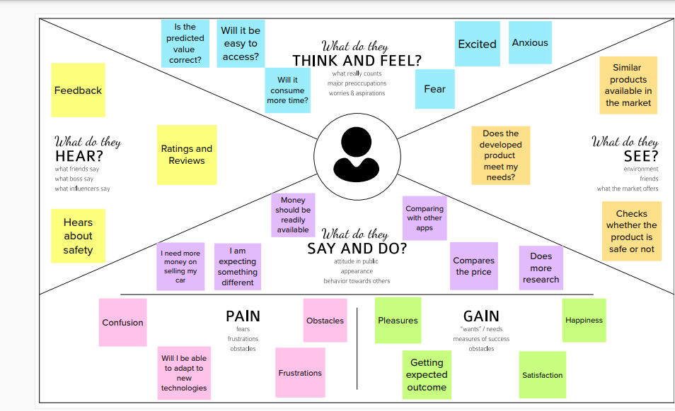

* 1. Ideation & Brainstorming

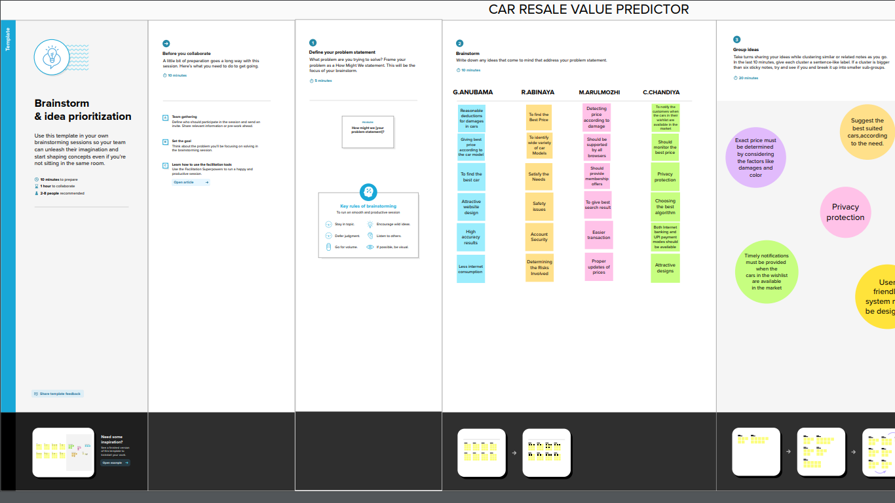

* 1. Proposed Solution

In order to predict the resale value of the car, we proposed an intelligent, flexible, and effective system that is based on using regression algorithms. Considering the main factors which would affect the resale value of a vehicle a regression model is to be built that would give the nearest resale value of the vehicle. We will be using various regression algorithms and algorithm with the best accuracy will be taken as a solution, then it will be integrated to the web-based application where the user is notified with the status of his product.

* 1. Problem Solution fit

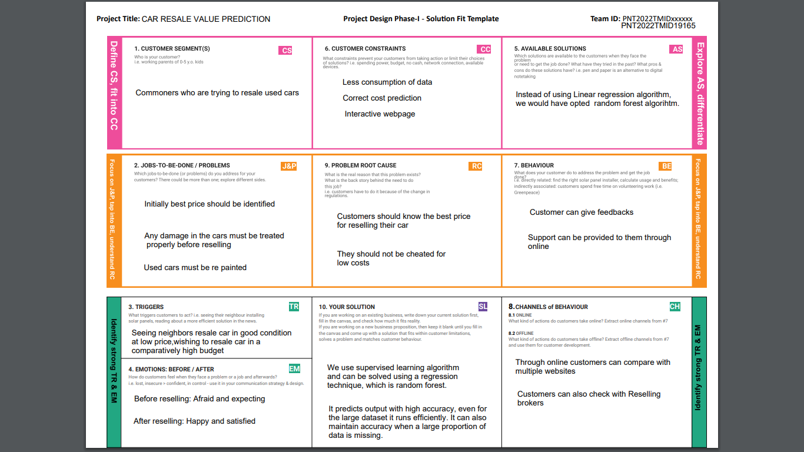

1. **REQUIREMENT ANALYSIS**
   1. ,

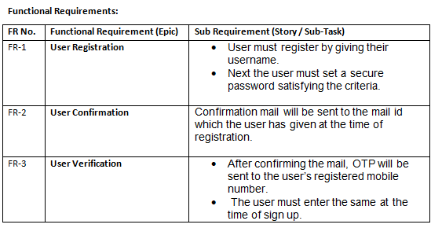

4.2

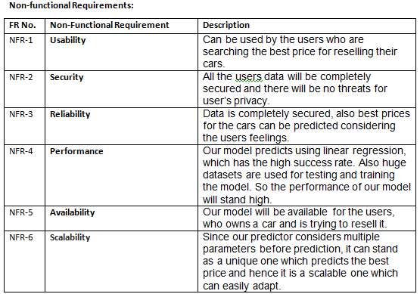

**5.PROJECT DESIGN**

* 1. Data Flow Diagrams

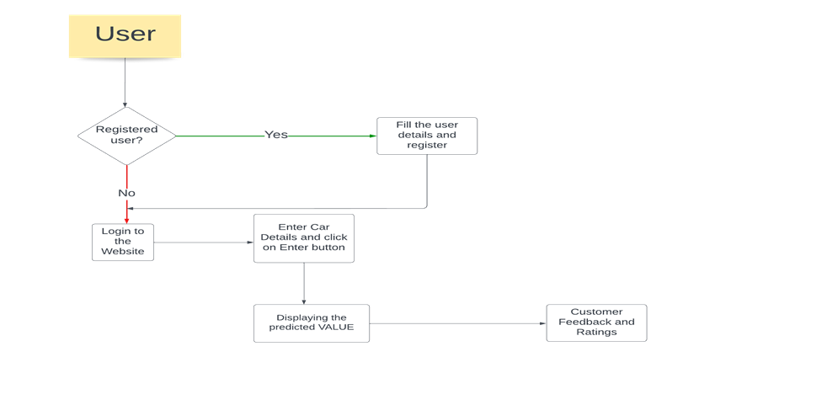

5.2 Solution & Technical Architecture

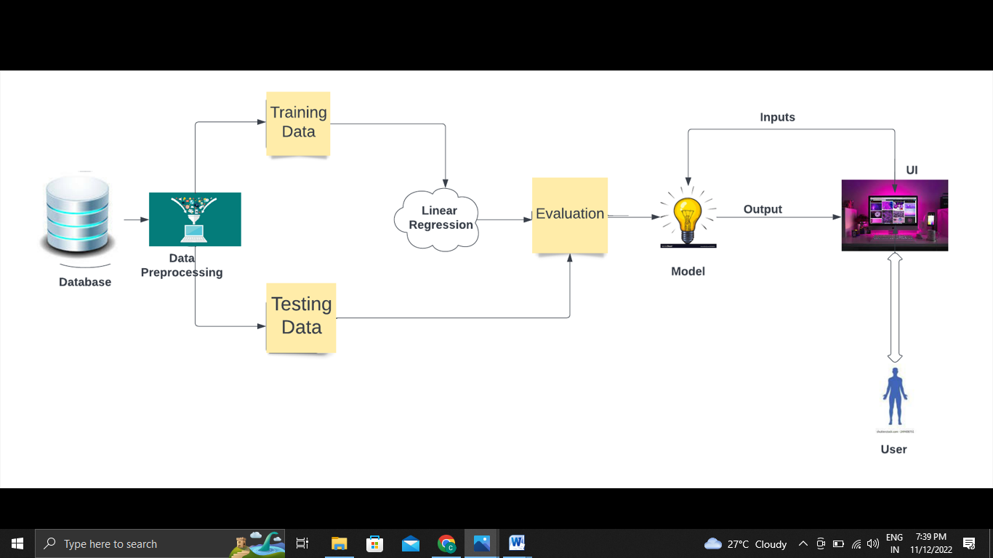

5.3 User Stories

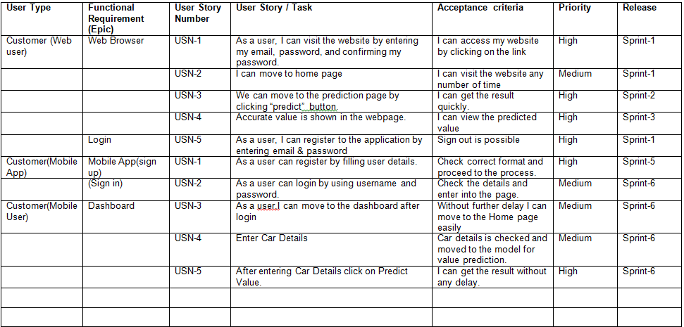

**6.PROJECT PLANNING & SCHEDULING**

* 1. Sprint Planning & Estimation

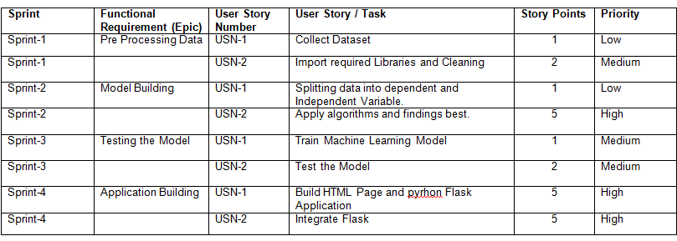

* 1. Sprint Delivery Schedule

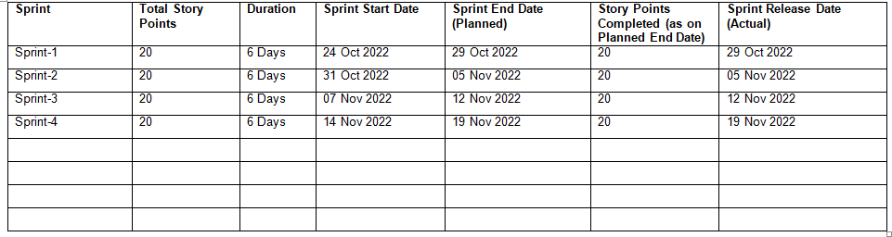

**7.CONCLUSION**

We started with understanding the use case of machine learning in the Automotive industry and how machine learning has transformed the driving experience. Moving onwe proposed an intelligent, flexible, and effective system that is based on using regression algorithms. Considering the main factors which would affect the resale value of a vehicle a regression model is to be built that would give the nearest resale value of the vehicle. We will be using various regression algorithms and algorithm with the best accuracy will be taken as a solution, then it will be integrated to the web-based application where the user is notified with the status of his product.

**8.FUTURE SCOPE**

Efficient use of deep learning such as LSTM (Long short term memory) or RNN (Recurrent Neural networks) can be implemented once enough data is collected. This can

improve accuracy and decrease RMSE drastically.

**9.APPENDIX**

**SOURCE CODE**

Welcomepage.html

<!DOCTYPE html>

|  |
| --- |
|  |
|  | <html> |
|  | <head> |
|  |  |
|  | <style> |
|  | .bodybackground{ |
|  | position: absolute; |
|  | left:20px; |
|  | top: 90px; |
|  | } |
|  | .content{ |
|  | position:absolute; |
|  | left:750px; |
|  | top:90px; |
|  | } |
|  | h1{text-align: center;} |
|  | </style> |
|  | </head> |
|  | <body> |
|  |  |
|  | <h1> Get the Accurate Resale Value of your Car!! </h1> |
|  | <hr> |
|  |  |
|  | <div class="bodybackground"> |
|  | <img src='C:\Users\S.MAHALAKSHMI\Desktop\pictures\image.jpg' height="500px" width="700px"></div> |
|  | <div class="content"> |
|  | <p>With difficult economic conditions,it is likely that sales of reconditioned second-hand cars will increase.In most of the countries,it is common to lease to lease a car rather than buying it outright.A lease is a binding contract between a buyer and a seller in which the buyer must pay fixed instalments for a pre defined number of months/years to the seller/financer.After the lease period is over,the buyer has the possibility to buy the car at its residual value,i.e.its expected resale value.Thus,this application is of commercial interest to seller/financers to be able to predict the residual value of cars with accuracy.</p> |
|  | <a href="resalepredict.html"> |
|  | <input type="button" value="RESALE VALUE OF YOUR CAR"> |
|  | </a> |
|  | </div> |
|  |  |
|  |  |
|  | </body> |
|  | </html>   |  | | --- | | RESALE.html | |  | <!DOCTYPE html>  <html lang="en" dir="ltr"> | |  | <head> | |  | <title>Car resale value</title> | |  |  | |  | </head> | |  | <body> | |  | <section class="form"> | |  | <form action="http://localhost:3000/predict" method="GET"> | |  | <table border="0" align="center"> | |  | <tbody> | |  | <h1>Get the Accurate Resale Value of Your Car</h1> | |  | <tr> | |  | <td><label for="year" padding:10px>Registration year : </label></td> | |  | <td><input id="year" maxlength="50" name="regyear" type="text" /> | |  | <br> | |  | <br> | |  | </td> | |  | </tr> | |  |  | |  | <tr> | |  | <td><label for="month">Registration Month : </label></td> | |  | <td><input id="month" maxlength="50" name="regmonth" type="text" /> | |  | <br> | |  | <br> | |  | </td> | |  | </tr> | |  |  | |  | <tr> | |  | <td><label for="power">Power of car in PS: </label></td> | |  | <td><input id="power" maxlength="50" name="powerps" type="text" /> | |  | <br> | |  | <br> | |  | </td> | |  | </tr> | |  |  | |  | <tr> | |  | <td><label for="kilometer">Kilometers that car have driven : </label></td> | |  | <td><input id="kilometer" maxlength="50" name="kms" type="text" /> | |  | <br> | |  | <br> | |  | </td> | |  | </tr> | |  |  | |  | <tr> | |  | <td><label for="geartype">Gear type : </label></td> | |  | <td><input type="radio" name="geartype" value="manual"/> Manual | |  | <input type="radio" name="geartype" value="automatic"/> Automatic | |  | <input type="radio" name="geartype" value="not-declared"/> Not declared | |  | <br> | |  | <br> | |  | </td> | |  | </tr> | |  |  | |  | <tr> | |  | <td><label for="damage">Your car is repaired or damaged : </label></td> | |  | <td><input type="radio" name="damage" value="yes"/> Yes | |  | <input type="radio" name="damage" value="no"/> No | |  | <input type="radio" name="damage" value="not-declared"/> Not declared | |  | <br> | |  | <br> | |  | </td> | |  | </tr> | |  |  | |  | <tr> | |  | <td><label for="model">Model Type : </label></td> | |  | <td> | |  | <select name="model" id="model"> | |  | <option value="" disabled selected hidden>Choose Model Name...</option> | |  | <option value="golf">Golf </option> | |  | <option value="grand">Grand </option> | |  | <option value="fabia">Fabia </option> | |  | <option value="3er">3er </option> | |  | <option value="2_reihe">2 Reihe </option> | |  | <option value="andere">Andere </option> | |  | <option value="c_max">C Max </option> | |  | <option value="3_reihe">3 Reihe </option> | |  | <option value="passat">Passat </option> | |  | <option value="navara">Navara </option> | |  | <option value="ka">Ka </option> | |  | <option value="polo">Polo </option> | |  | <option value="twingo">Twingo </option> | |  | <option value="a_klasse">A klasse </option> | |  | <option value="scirocco">Scirocco </option> | |  | <option value="5er">5er </option> | |  | <option value="meriva">Meriva </option> | |  | <option value="arosa">Arosa </option> | |  | <option value="c4">C4 </option> | |  | <option value="civic">Civic </option> | |  | <option value="transporter">Transporter </option> | |  | <option value="punto">Punto </option> | |  | <option value="e_klasse">E Klasse </option> | |  | <option value="clio">Clio </option> | |  | <option value="kadett">Kadett </option> | |  | <option value="kangoo">Kangoo </option> | |  | <option value="corsa">Corsa </option> | |  | <option value="one">One </option> | |  | <option value="fortwo">Fortwo </option> | |  | <option value="1er">1er </option> | |  | <option value="b_klasse">B Klasse </option> | |  | <option value="signum">Signum </option> | |  | <option value="astra">Astra </option> | |  | <option value="a8">A8 </option> | |  | <option value="jetta">Jetta </option> | |  | <option value="fiesta">Fiesta </option> | |  | <option value="c_klasse">C Klasse </option> | |  | <option value="micra">Micra </option> | |  | <option value="vito">Vito </option> | |  | <option value="sprinter">Sprinter </option> | |  | <option value="156">156 </option> | |  | <option value="escort">Escort </option> | |  | <option value="forester">Forester </option> | |  | <option value="xc_reihe">Xc Reihe </option> | |  | <option value="scenic">Scenic </option> | |  | <option value="a4">A4 </option> | |  | <option value="a1">A1 </option> | |  | <option value="insignia">Insignia </option> | |  | <option value="combo">Combo </option> | |  | <option value="focus">Focus </option> | |  | <option value="tt">Tt </option> | |  | <option value="a6">A6 </option> | |  | <option value="jazz">Jazz </option> | |  | <option value="omega">Omega </option> | |  | <option value="slk">Slk </option> | |  | <option value="7er">7er </option> | |  | <option value="80">80 </option> | |  | <option value="147">147 </option> | |  | <option value="glk">Glk </option> | |  | <option value="100">100 </option> | |  | <option value="z_reihe">Z Reihe </option> | |  | <option value="sportage">Sportage </option> | |  | <option value="sorento">Sorento </option> | |  | <option value="v40">V40 </option> | |  | <option value="5er">5er </option> | |  | <option value="ibiza">Ibiza </option> | |  | <option value="3er">3er </option> | |  | <option value="mustang">Mustang </option> | |  | <option value="eos">Eos </option> | |  | <option value="touran">Touran </option> | |  | <option value="getz">Getz </option> | |  | <option value="a3">A3 </option> | |  | <option value="almera">Almera </option> | |  | <option value="megane">Megane </option> | |  | <option value="7er">7er </option> | |  | <option value="1er">1er </option> | |  | <option value="lupo">Lupo </option> | |  | <option value="r19">R19 </option> | |  | <option value="zafira">Zafira </option> | |  | <option value="caddy">Caddy </option> | |  | <option value="2_reihe">2 Reihe </option> | |  | <option value="mondeo">Mondeo </option> | |  | <option value="cordoba">Cordoba </option> | |  | <option value="colt">Colt </option> | |  | <option value="impreza">Impreza </option> | |  | <option value="vectra">Vectra </option> | |  | <option value="berlingo">Berlingo </option> | |  | <option value="80">80 </option> | |  | <option value="m_klasse">M Klasse </option> | |  | <option value="tiguan">Tiguan </option> | |  | <option value="i_reihe">I Reihe </option> | |  | <option value="espace">Espace </option> | |  | <option value="sharan">Sharan </option> | |  | <option value="6_reihe">6 Reihe </option> | |  | <option value="panda">Panda </option> | |  | <option value="up">Up </option> | |  | <option value="seicento">Seicento </option> | |  | <option value="ceed">Ceed </option> | |  | <option value="5_reihe">5 Reihe </option> | |  | <option value="yeti">Yeti </option> | |  | <option value="octavia">Octavia </option> | |  | <option value="mii">Mii </option> | |  | <option value="rx_reihe">Rx Reihe </option> | |  | <option value="6er">6er </option> | |  | <option value="modus">Modus </option> | |  | <option value="fox">Fox </option> | |  | <option value="matiz">Matiz </option> | |  | <option value="beetle">Beetle </option> | |  | <option value="c1">C1 </option> | |  | <option value="rio">Rio </option> | |  | <option value="touareg">Touareg </option> | |  | <option value="logan">Logan </option> | |  | <option value="spider">Spider </option> | |  | <option value="cuore">Cuore </option> | |  | <option value="s_max">S Max </option> | |  | <option value="a2">A2 </option> | |  | <option value="x_reihe">X Reihe </option> | |  | <option value="a5">A5 </option> | |  | <option value="galaxy">Galaxy </option> | |  | <option value="c3">C3 </option> | |  | <option value="viano">Viano </option> | |  | <option value="s_klasse">S Klasse </option> | |  | <option value="1_reihe">1 Reihe </option> | |  | <option value="avensis">Avensis </option> | |  | <option value="sl">Sl </option> | |  | <option value="roomster">Roomster </option> | |  | <option value="q5">Q5 </option> | |  | <option value="kaefer">Kaefer </option> | |  | <option value="santa">Santa </option> | |  | <option value="cooper">Cooper </option> | |  | <option value="leon">Leon </option> | |  | <option value="4_reihe">4 Reihe </option> | |  | <option value="500">500 </option> | |  | <option value="laguna">Laguna </option> | |  | <option value="ptcruiser">Ptcruiser </option> | |  | <option value="clk">Clk </option> | |  | <option value="primera">Primera </option> | |  | <option value="exeo">Exeo </option> | |  | <option value="159">159 </option> | |  | <option value="transit">Transit </option> | |  | <option value="juke">Juke </option> | |  | <option value="qashqai">Qashqai </option> | |  | <option value="carisma">Carisma </option> | |  | <option value="accord">Accord </option> | |  | <option value="corolla">Corolla </option> | |  | <option value="lanos">Lanos </option> | |  | <option value="phaeton">Phaeton </option> | |  | <option value="boxster">Boxster </option> | |  | <option value="verso">Verso </option> | |  | <option value="swift">Swift </option> | |  | <option value="rav">Rav </option> | |  | <option value="kuga">Kuga </option> | |  | <option value="picanto">Picanto </option> | |  | <option value="kalos">Kalos </option> | |  | <option value="superb">Superb </option> | |  | <option value="stilo">Stilo </option> | |  | <option value="alhambra">Alhambra </option> | |  | <option value="911">911 </option> | |  | <option value="mx_reihe">Mx Reihe </option> | |  | <option value="m_reihe">M Reihe </option> | |  | <option value="roadster">Roadster </option> | |  | <option value="ypsilon">Ypsilon </option> | |  | <option value="cayenne">Cayenne </option> | |  | <option value="galant">Galant </option> | |  | <option value="justy">Justy </option> | |  | <option value="90">90 </option> | |  | <option value="sirion">Sirion </option> | |  | <option value="crossfire">Crossfire </option> | |  | <option value="6_reihe">6 Reihe </option> | |  | <option value="agila">Agila </option> | |  | <option value="duster">Duster </option> | |  | <option value="cr_reihe">Cr Reihe </option> | |  | <option value="v50">V50 </option> | |  | <option value="discovery">Discovery </option> | |  | <option value="c_reihe">C Reihe </option> | |  | <option value="v_klasse">V Klasse </option> | |  | <option value="yaris">Yaris </option> | |  | <option value="c5">C5 </option> | |  | <option value="aygo">Aygo </option> | |  | <option value="cc">Cc </option> | |  | <option value="carnival">Carnival </option> | |  | <option value="fusion">Fusion </option> | |  | <option value="bora">Bora </option> | |  | <option value="forfour">Forfour </option> | |  | <option value="100">100 </option> | |  | <option value="cl">Cl </option> | |  | <option value="tigra">Tigra </option> | |  | <option value="156">156 </option> | |  | <option value="300c">300c </option> | |  | <option value="100">100 </option> | |  | <option value="147">147 </option> | |  | <option value="q3">Q3 </option> | |  | <option value="spark">Spark </option> | |  | <option value="v70">V70 </option> | |  | <option value="x_type">X Type </option> | |  | <option value="5_reihe">5 Reihe </option> | |  | <option value="ducato">Ducato </option> | |  | <option value="s_type">S Type </option> | |  | <option value="x_trail">X Trail </option> | |  | <option value="toledo">Toledo </option> | |  | <option value="altea">Altea </option> | |  | <option value="7er">7er </option> | |  | <option value="voyager">Voyager </option> | |  | <option value="calibra">Calibra </option> | |  | <option value="bravo">Bravo </option> | |  | <option value="range_rover">Range Rover </option> | |  | <option value="antara">Antara </option> | |  | <option value="tucson">Tucson </option> | |  | <option value="q7">Q7 </option> | |  | <option value="citigo">Citigo </option> | |  | <option value="jimny">Jimny </option> | |  | <option value="cx_reihe">Cx Reihe </option> | |  | <option value="wrangler">Wrangler </option> | |  | <option value="lybra">Lybra </option> | |  | <option value="range_rover_sport">Range Rover Sport </option> | |  | <option value="lancer">Lancer </option> | |  | <option value="159">159 </option> | |  | <option value="freelander">Freelander </option> | |  | <option value="captiva">Captiva </option> | |  | <option value="c2">C2 </option> | |  | <option value="500">500 </option> | |  | <option value="range_rover_evoque">Range Rover Evoque </option> | |  | <option value="sandero">Sandero </option> | |  | <option value="note">Note </option> | |  | <option value="900">900 </option> | |  | <option value="147">147 </option> | |  | <option value="defender">Defender </option> | |  | <option value="cherokee">Cherokee </option> | |  | <option value="clubman">Clubman </option> | |  | <option value="samara">Samara </option> | |  | <option value="2_reihe">2 Reihe </option> | |  | <option value="1er">1er </option> | |  | <option value="3er">3er </option> | |  | <option value="601">601 </option> | |  | <option value="3_reihe">3 Reihe </option> | |  | <option value="4_reihe">4 Reihe </option> | |  | <option value="5er">5er </option> | |  | <option value="6_reihe">6 Reihe </option> | |  | <option value="legacy">Legacy </option> | |  | <option value="pajero">Pajero </option> | |  | <option value="auris">Auris </option> | |  | <option value="niva">Niva </option> | |  | <option value="5_reihe">5 Reihe </option> | |  | <option value="s60">S60 </option> | |  | <option value="nubira">Nubira </option> | |  | <option value="vivaro">Vivaro </option> | |  | <option value="g_klasse">G Klasse </option> | |  | <option value="lodgy">Lodgy </option> | |  | <option value="850">850 </option> | |  | <option value="serie_2">Serie 2 </option> | |  | <option value="6er">6er </option> | |  | <option value="charade">Charade </option> | |  | <option value="croma">Croma </option> | |  | <option value="outlander">Outlander </option> | |  | <option value="gl">Gl </option> | |  | <option value="doblo">Doblo </option> | |  | <option value="musa">Musa </option> | |  | <option value="amarok">Amarok </option> | |  | <option value="156">156 </option> | |  | <option value="move">Move </option> | |  | <option value="9000">9000 </option> | |  | <option value="v60">V60 </option> | |  | <option value="145">145 </option> | |  | <option value="aveo">Aveo </option> | |  | <option value="200">200 </option> | |  | <option value="300c">300c </option> | |  | <option value="b_max">B Max </option> | |  | <option value="delta">Delta </option> | |  | <option value="terios">Terios </option> | |  | <option value="rangerover">RangeRover </option> | |  | <option value="90">90 </option> | |  | <option value="materia">Materia </option> | |  | <option value="kalina">Kalina </option> | |  | <option value="elefantino">Elefantino </option> | |  | <option value="i3">I3 </option> | |  | <option value="kappa">Kappa </option> | |  | <option value="serie_3">Serie 3 </option> | |  | <option value="48429">48429 </option> | |  | <option value="serie_1">Serie 1 </option> | |  | <option value="discovery_sport">Discovery Sport </option> | |  |  | |  | </select> | |  | <br> | |  | <br> | |  | </td> | |  | </tr> | |  |  | |  | <tr> | |  | <td><label for="brand">Brand :</label></td> | |  | <td> | |  | <select name="brand" id="brand"> | |  | <option value="" disabled selected hidden>Choose Brand Name...</option> | |  | <option value="volkswagen">Volkswagen </option> | |  | <option value="audi">Audi </option> | |  | <option value="jeep">Jeep </option> | |  | <option value="skoda">Skoda </option> | |  | <option value="bmw">Bmw </option> | |  | <option value="peugeot">Peugeot </option> | |  | <option value="ford">Ford </option> | |  | <option value="mazda">Mazda </option> | |  | <option value="nissan">Nissan </option> | |  | <option value="renault">Renault </option> | |  | <option value="mercedes_benz">Mercedes Benz </option> | |  | <option value="opel">Opel </option> | |  | <option value="seat">Seat </option> | |  | <option value="citroen">Citroen </option> | |  | <option value="honda">Honda </option> | |  | <option value="fiat">Fiat </option> | |  | <option value="mini">Mini </option> | |  | <option value="smart">Smart </option> | |  | <option value="hyundai">Hyundai </option> | |  | <option value="sonstige_autos">Sonstige Autos </option> | |  | <option value="alfa_romeo">Alfa Romeo </option> | |  | <option value="subaru">Subaru </option> | |  | <option value="volvo">Volvo </option> | |  | <option value="mitsubishi">Mitsubishi </option> | |  | <option value="kia">Kia </option> | |  | <option value="suzuki">Suzuki </option> | |  | <option value="lancia">Lancia </option> | |  | <option value="porsche">Porsche </option> | |  | <option value="toyota">Toyota </option> | |  | <option value="chevrolet">Chevrolet </option> | |  | <option value="dacia">Dacia </option> | |  | <option value="daihatsu">Daihatsu </option> | |  | <option value="trabant">Trabant </option> | |  | <option value="saab">Saab </option> | |  | <option value="chrysler">Chrysler </option> | |  | <option value="jaguar">Jaguar </option> | |  | <option value="daewoo">Daewoo </option> | |  | <option value="rover">Rover </option> | |  | <option value="land_rover">Land Rover </option> | |  | <option value="lada">Lada </option> | |  | </select> | |  | <br> | |  | <br> | |  | </td> | |  | </tr> | |  |  | |  | <tr> | |  | <td><label for="fuelType">Fuel Type :</label></td> | |  | <td> | |  | <select name="fuelType" id="brand"> | |  | <option value="" disabled selected hidden>Choose Fuel Type...</option> | |  | <option value="petrol"> Petrol </option> | |  | <option value="diesel"> Diesel </option> | |  | <option value="not-declared"> Not Declared </option> | |  | <option value="lpg">LPG </option> | |  | <option value="cng">CNG </option> | |  | <option value="hybrid">Hybrid </option> | |  | <option value="others">Others </option> | |  | <option value="electric">Electric </option> | |  | </select> | |  | <br> | |  | <br> | |  | </td> | |  | </tr> | |  |  | |  | <tr> | |  | <td><label for="vehicletype">Vehicle type:</label></td> | |  | <td> | |  | <select name="vehicletype" id="vehicle" > | |  | <option value="" disabled selected hidden>Choose Vehicle Type...</option> | |  | <option value="coupe">Coupe </option> | |  | <option value="suv">SUV </option> | |  | <option value="kleinwagen">Kleinwagen </option> | |  | <option value="limousine">Limousine </option> | |  | <option value="cabrio">Cabrio </option> | |  | <option value="bus">Bus </option> | |  | <option value="kombi">Kombi </option> | |  | <option value="andere">Andere </option> | |  | <option value="volkswagen">Volkswagen </option> | |  | </select> | |  | <br> | |  | <br> | |  | </td> | |  | </tr> | |  | </tbody> | |  | </table> | |  | <input name="Submit" type="Submit" value="Submit" id="button"/> | |  | </form> | |  | </section> | |  |  | |  | </body | |  | </html> | |

Predictpage.html

|  |
| --- |
|  |
|  | <!DOCTYPE html>  <html lang="en"> |
|  | <head> |
|  | <meta charset="UTF-8"> |
|  | <meta http-equiv="X-UA-Compatible" content="IE=edge"> |
|  | <meta name="viewport" content="width=device-width, initial-scale=1.0"> |
|  | <link rel="stylesheet" href="../static/css/predict.css"> |
|  | <title>Car Resale Predicted Value</title> |
|  | </head> |
|  | <body> |
|  | <section class="header"> |
|  | <nav> |
|  | <a href="/"><img src="../static/Images/sang.png" width="100" height="100"></a> |
|  | </nav> |
|  | <div class="text-box"> |
|  | <h1>The Predicted Car Resale Value is </h1> |
|  | <h1>{{predict}}</h1> |
|  | </div> |
|  | </section> |
|  |  |
|  |  |
|  | </body> |
|  | </html> |

Prediction.py

import numpy as np

import pandas as pd

import matplotlib.pyplot as plt

import seaborn as sns

%matplotlib inline

df=pd.read_csv('/content/Car resale-train.csv')

df.head()

df.shape

df.columns

df['car_name'].value_counts()

df.info()

df.duplicated().sum()

df.isnull().sum()

corr=df.corr()

corr

corr = df.corr()

sns.set_context("notebook", font_scale=1.0, rc={"lines.linewidth": 2.5})

plt.figure(figsize=(13,7))

a = sns.heatmap(corr, annot=True, fmt='.2f')

rotx = a.set_xticklabels(a.get_xticklabels(), rotation=90)

roty = a.set_yticklabels(a.get_yticklabels(), rotation=30)

def remove(df):

df1=df.drop(['id','emi_starts_from','original_price','broker_quote'],axis=1)

return df1

df1=remove(df)

df1.dtypes

category_columns=df1.select_dtypes(include=['object']).columns.tolist()

integer_columns=df1.select_dtypes(include=['int64','float64']).columns.tolist()

for column in df1:

if df1[column].isnull().any():

if(column in category_columns):

df1[column]=df1[column].fillna(df1[column].mode()[0])

else:

df1[column]=df1[column].fillna(df1[column].mean)

df1.isnull().sum()

sns.heatmap(df1.isnull(),yticklabels=False,cbar=False,cmap='YlGnBu')

df1.describe(include='object')

for i in integer_columns:

plt.figure()

sns.boxplot(x=df1[i])

max_km=df1['kms_run'].max()

max_km

df1=df1[df1['times_viewed']<20000]

df1.shape

for i in integer_columns:

plt.figure()

sns.boxplot(x=df1[i])

plt.figure(figsize=(12,8))

sns.set(rc={'axes.facecolor':'#283747','axes.grid': True,'xtick.labelsize':16})

sns.lineplot(x='kms_run',y='sale_price',data=df1)

plt.figure(figsize=(12,8))

sns.set(rc={'axes.facecolor':'white','axes.grid': True,'xtick.labelsize':16})

sns.lineplot(x='yr_mfr',y='sale_price',data=df1,hue='transmission')

plt.figure(figsize=(12,8))

sns.set(rc={'axes.facecolor':'white','axes.grid': False,'xtick.labelsize':16})

sns.lineplot(x='yr_mfr',y='sale_price',data=df,hue='body_type')

plt.figure(figsize=(12,8))

sns.set(rc={'axes.facecolor':'#283747','axes.grid': True,'xtick.labelsize':16})

sns.barplot(df['city'],df['sale_price'])

plt.xticks(rotation=45)

df_test=pd.read_csv('/content/Car resale-test.csv')

cateogry_columns=df_test1.select_dtypes(include=['object']).columns.tolist()

integer_columns=df_test1.select_dtypes(include=['int64','float64']).columns.tolist()

for column in df_test1:

if df_test1[column].isnull().any():

if(column in cateogry_columns):

df_test1[column]=df_test1[column].fillna(df_test1[column].mode()[0])

else:

df_test1[column]=df_test1[column].fillna(df_test1[column].mean)

df_test1.isnull().sum()

X_train=df1.drop('sale_price',axis=1)

Y_train=df1['sale_price'].values

from sklearn.preprocessing import StandardScaler

sc = StandardScaler()

# get numeric data

num_d = X_train.select_dtypes(exclude=['object'])

# update the cols with their normalized values

X_train[num_d.columns] = sc.fit_transform(num_d)

from sklearn import preprocessing

# label_encoder object knows how to understand word labels.

label_encoder = preprocessing.LabelEncoder()

# Encode labels in categorical_column

for i in category_columns:

X_train[i]= label_encoder.fit_transform(X_train[i])

X_train1=X_train.values

X_test=df_test1.drop('sale_price',axis=1)

Y_test=df_test1['sale_price'].values

from sklearn.preprocessing import StandardScaler

sc = StandardScaler()

# get numeric data

num_d = X_test.select_dtypes(exclude=['object'])

# update the cols with their normalized values

X_test[num_d.columns] = sc.fit_transform(num_d)

from sklearn import preprocessing

# label_encoder object knows how to understand word labels.

label_encoder = preprocessing.LabelEncoder()

# Encode labels in categorical_column

for i in category_columns:

X_test[i]= label_encoder.fit_transform(X_test[i])

X_test1=X_test.values

X_test1

from sklearn.linear_model import LinearRegression

lr=LinearRegression()

lr.fit(X_train1,Y_train)

y_pred=lr.predict(X_test1)

tsc1=lr.score(X_test1,Y_test)

tsc1

sc1=lr.score(X_train1,Y_train)

sc1

from sklearn.linear_model import Lasso

lasso_reg = Lasso()

lasso_reg.fit(X_train1,Y_train)

y_pred2=lasso_reg.predict(X_test1)

tsc2=lasso_reg.score(X_train1,Y_train)

tsc2

sc2=lasso_reg.score(X_test1,Y_test)

sc2

from sklearn.linear_model import Ridge

ridge_reg=Ridge()

ridge_reg.fit(X_train1,Y_train)

y_pred3=ridge_reg.predict(X_test1)

tsc3=ridge_reg.score(X_train1,Y_train)

tsc3

sc3=ridge_reg.score(X_test1,Y_test)

sc3

from sklearn.ensemble import RandomForestRegressor

regressor = RandomForestRegressor(n_estimators = 20, random_state = 0)

regressor.fit(X_train1, Y_train)

y_pred4=regressor.predict(X_test1)

tsc4=regressor.score(X_train1,Y_train)

tsc4

sc4=regressor.score(X_test1,Y_test)

sc4

from sklearn.metrics import mean_squared_error,mean_absolute_error

def metric(y_test,y_predict):

mae=mean_absolute_error(y_test,y_predict) #mean_absolute_error

mse=mean_squared_error(y_test,y_predict) #mean_squared_error

rmse=mean_squared_error(y_test,y_predict,squared=False)

return [mae,mse,rmse]

linearregressoin=metric(Y_test,y_pred)

linearregressoin.append(sc1)

linearregressoin.append(tsc1)

linearregressoin

lassoregression=metric(Y_test,y_pred2)

lassoregression.append(sc2)

lassoregression.append(tsc2)

lassoregression

Ridgeregression=metric(Y_test,y_pred3)

Ridgeregression.append(sc3)

Ridgeregression.append(tsc3)

Ridgeregression

RandomForestRegressor=metric(Y_test,y_pred4)

RandomForestRegressor.append(sc4)

RandomForestRegressor.append(tsc4)

RandomForestRegressor

algorithms=['Linear Regression','Lasso Regression','Ridge Regression','Random Forest Regression']

eval=pd.DataFrame([linearregressoin,lassoregression,Ridgeregression,RandomForestRegressor],columns=['Mean Squared Error','Mean Absolute Error','Root Mean SquareError','Test Score','Train Score'],index=algorithms)

eval

score=[]

for i in range(4):

score.append(eval.iloc[:,3][i])

score

plt.figure(figsize=(15,7))

plt.scatter(algorithms,score,linewidth=2,s=50,marker='s',edgecolors='green')

plt.xlabel("Regression Models")

plt.ylabel("Scores")

plt.title("Algorithm Comparison")

plt.show()

df=pd.DataFrame(score,index=algorithms,columns=['score'])

df

algo=['lr','lasso','ridge','rfr','xgbr']

ind = np.arange(len(score)) # the x locations for the groups

width = 0.35 # the width of the bars

fig,ax = plt.subplots()

rects1 = ax.bar(ind - width/2, eval['Mean Squared Error'], width,

label='mse')

rects2 = ax.bar(ind + width/2, eval['Root Mean SquareError'], width,

label='rmse')

ax.set_ylabel('Scores')

ax.set_title('Algorithm performance')

ax.set_xticks(ind)

ax.set_xticklabels(algo)

ax.legend()

def autolabel(rects, xpos='center'):

ha = {'center': 'center', 'right': 'left', 'left': 'right'}

offset = {'center': 0, 'right': 1, 'left': -1}

for rect in rects:

height = rect.get_height()

ax.annotate('{}'.format(height),

xy=(rect.get_x() + rect.get_width() / 2, height),

xytext=(offset[xpos]*3, 3), # use 3 points offset

textcoords="offset points", # in both directions

ha=ha[xpos], va='bottom')

fig.tight_layout()

plt.show()

df=pd.DataFrame([eval['Mean Squared Error'],eval['Root Mean SquareError']],columns=algorithms,index=['mse','rmse'])

df

**GITHUB LINK**

**https://github.com/IBM-EPBL/IBM-Project-5585-1658810516**